**Project 2**

**<Hangman Extreme>**

**CSC-17C (42475)**

**Name: Kevin Vo**

**Date: 04/16/18**

**Introduction**

**Title: Hangman Extreme**

Classic Hangman is an interactive word guessing game where the player has a certain amount of turns before the full image of a man hanging appears.

Each time a word unknown to the player will be selected with a graphical representation indicating the amount of letters this word has. The player is then requested to enter a letter that they think is present in the unknown word. Guess enough letters correctly that makes up the full word before the entire hanging man image appears. The appearance of the image of the hanging man is dependent on the amount of incorrect letters that were inputted as each time a part of his body reveals itself.

Hangman Extreme is based off the classic Hangman game but has some additional modes and features embedded into it.

There is a “Normal Mode” that is closest to the original version of the game that’s mentioned above. Within this game mode you have features such as the “Guess Word” ability to guess the entire word to complete your turn/game quicker but in return you will lose the game if you guess the wrong word. The “Lifeline” feature that allows you to guess the word as well but is not a sudden lose if you were to guess wrongly; however, this feature is only available once per turn. You’ll also have the ability to view your previous inputs for the current round (called “View Inputs”).

The second game type is called “Ez-Mode”. Within this mode of Hangman Extreme, there’s only a list of potentially 25 randomly selected words from a list of over 800. On top of that, these words will display for you in alphabetical order for you to better guess the word. The features: “Guess Word”, “Lifeline”, and “View Inputs” is also available for “Ez-Mode” along with the processing game modes that will be mentioned below.

The third game mode is potentially the longest out of all the game modes, (hence the name “Marathon Mode”) as the player is able to select the number rounds with a randomly selected word per each round. The player has to win each round as they have done before for all of the rounds to finish.

The last game mode is called “Custom Word Mode” where the player can choose the number of rounds for another person to play as they enter word(s) of their choice for each number of rounds that they have chosen. These words will them be collected and inserted into the library of the game so that they can later be called in the future.

**Summary**

Project Size: ~1413

Number of Variables: 18+

Number of Functions/Methods: 35

Number of Classes: 3

Types of Containers Used: 5

Besides surpassing the minimum requirements of 750 lines of code, I have utilized Maps, Sets, Lists, and Queues with Iterators and Algorithms from the STL Library.

I used the **STL’s Map** ability of pairing data to store and display players’ usernames along with their score. The reason why map was chosen instead of multimap is to avoid repeats of players having the same name.

I used the **STL’s Set** container to potentially store the 25 randomly chosen words as mentioned above for “Ez-Mode”. The reason why this was picked as like maps, it’s a self-sorting container so that the player is able to view their clean list of words in alphabetical order and on top of the fact that it disallow repeats.

**STL’s Lists** were used to collect recently inputted letters and/or word for the round so that the player is able to see what they’ve already guess. I chose Lists for this purpose because of it is not a sorted-container so that the player can see a drop down list of their own inputs from newest to oldest.

**STL’s Stacks** were used to store words for marathon mode. Stack was chosen for this task as it can remain unsorted and the data stored into it in this case only requires to be used once and forgotten; therefore, popping elements was not an issue. Its LIFO characteristic was also did not have any drawbacks in this case as well.

**STL’s Queues** we used to display the Custom Words there were inputted into the game by the player. The game utilizes the queues’ FIFO characteristic to help the player easily determine which word will be used for which round and once again.

**Iterators** were used to traverse Sets and Maps as they’re used to access some or all of its elements.

**Algorithms** were used to sort the words that the user has inputted by his/her choice, check if a value is present on a Map dealing with usernames and scores, and to remove a word from a Set in EZ-Mode if the player wishes to do so.

It was challenging to decide which contain to use for which purpose in the game; that is why each game mode was designed around using the container that was intended for it. All together it took me over half a week to figure out what to do with the game to meet the requirements, code it, and fixed the bugs that had been caught.

**Description**

The main point of this program is to use the map, set, lists, stack, and queue containers from the STL Library along with its Iterators and Algorithms.

The uses of these containers, iterators, and algorithms are listed above under **Summary**.

**Sample Input/Output**

Start of Hangman Extreme (menu):

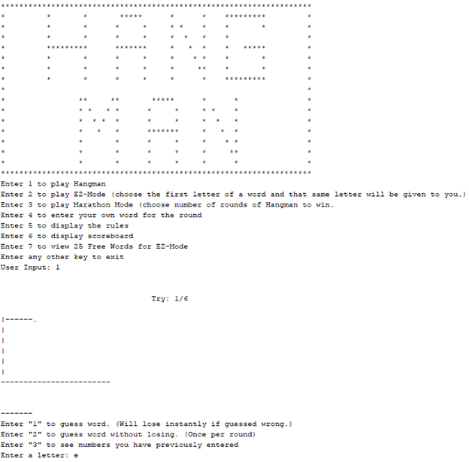

Gameplay with selectable features:

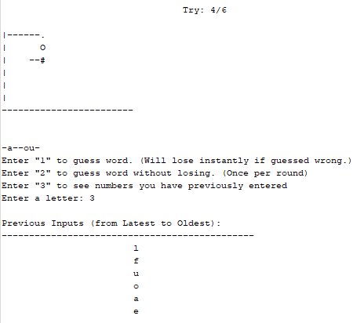

Endgame – Request to document score:

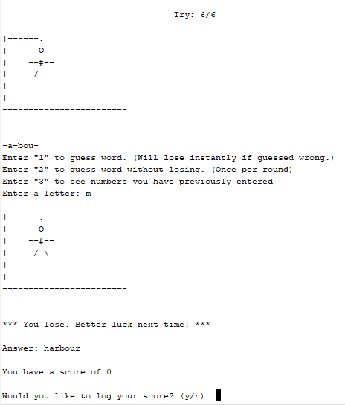

**Flowchart**

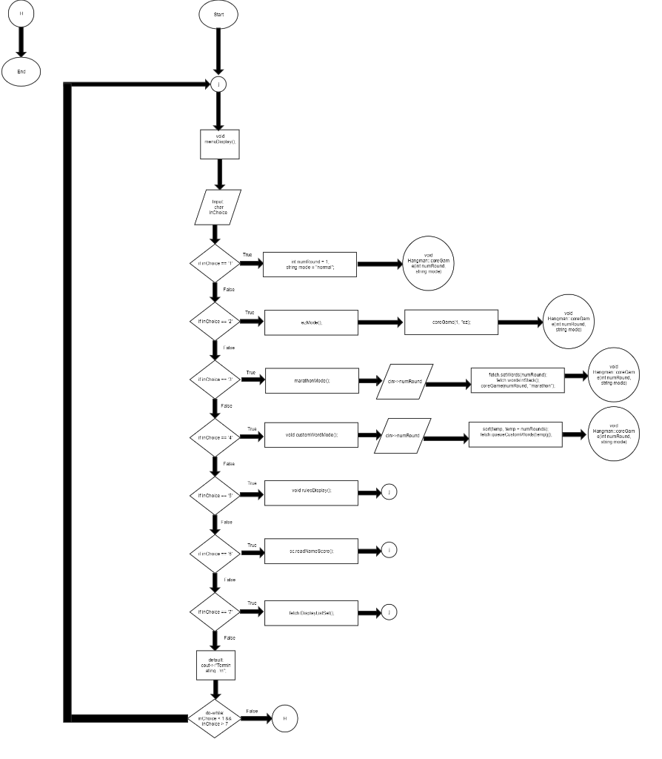

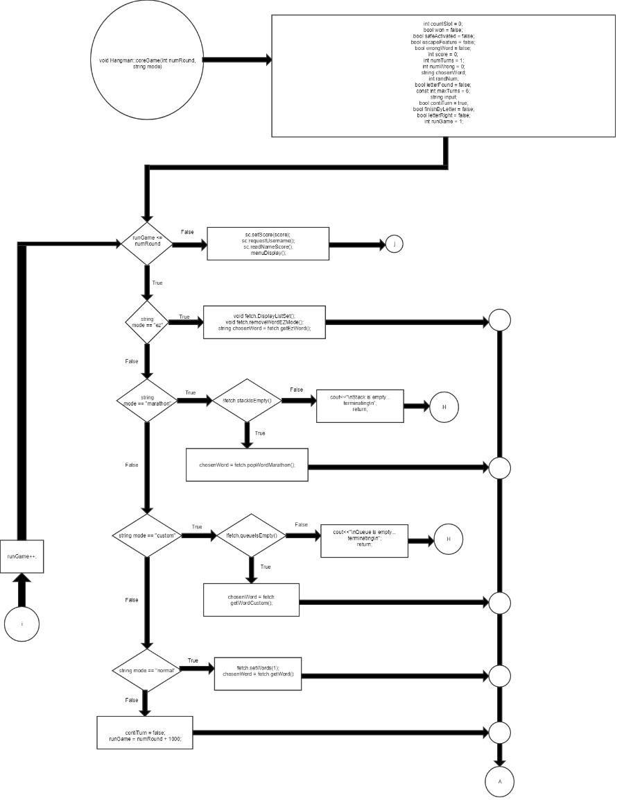

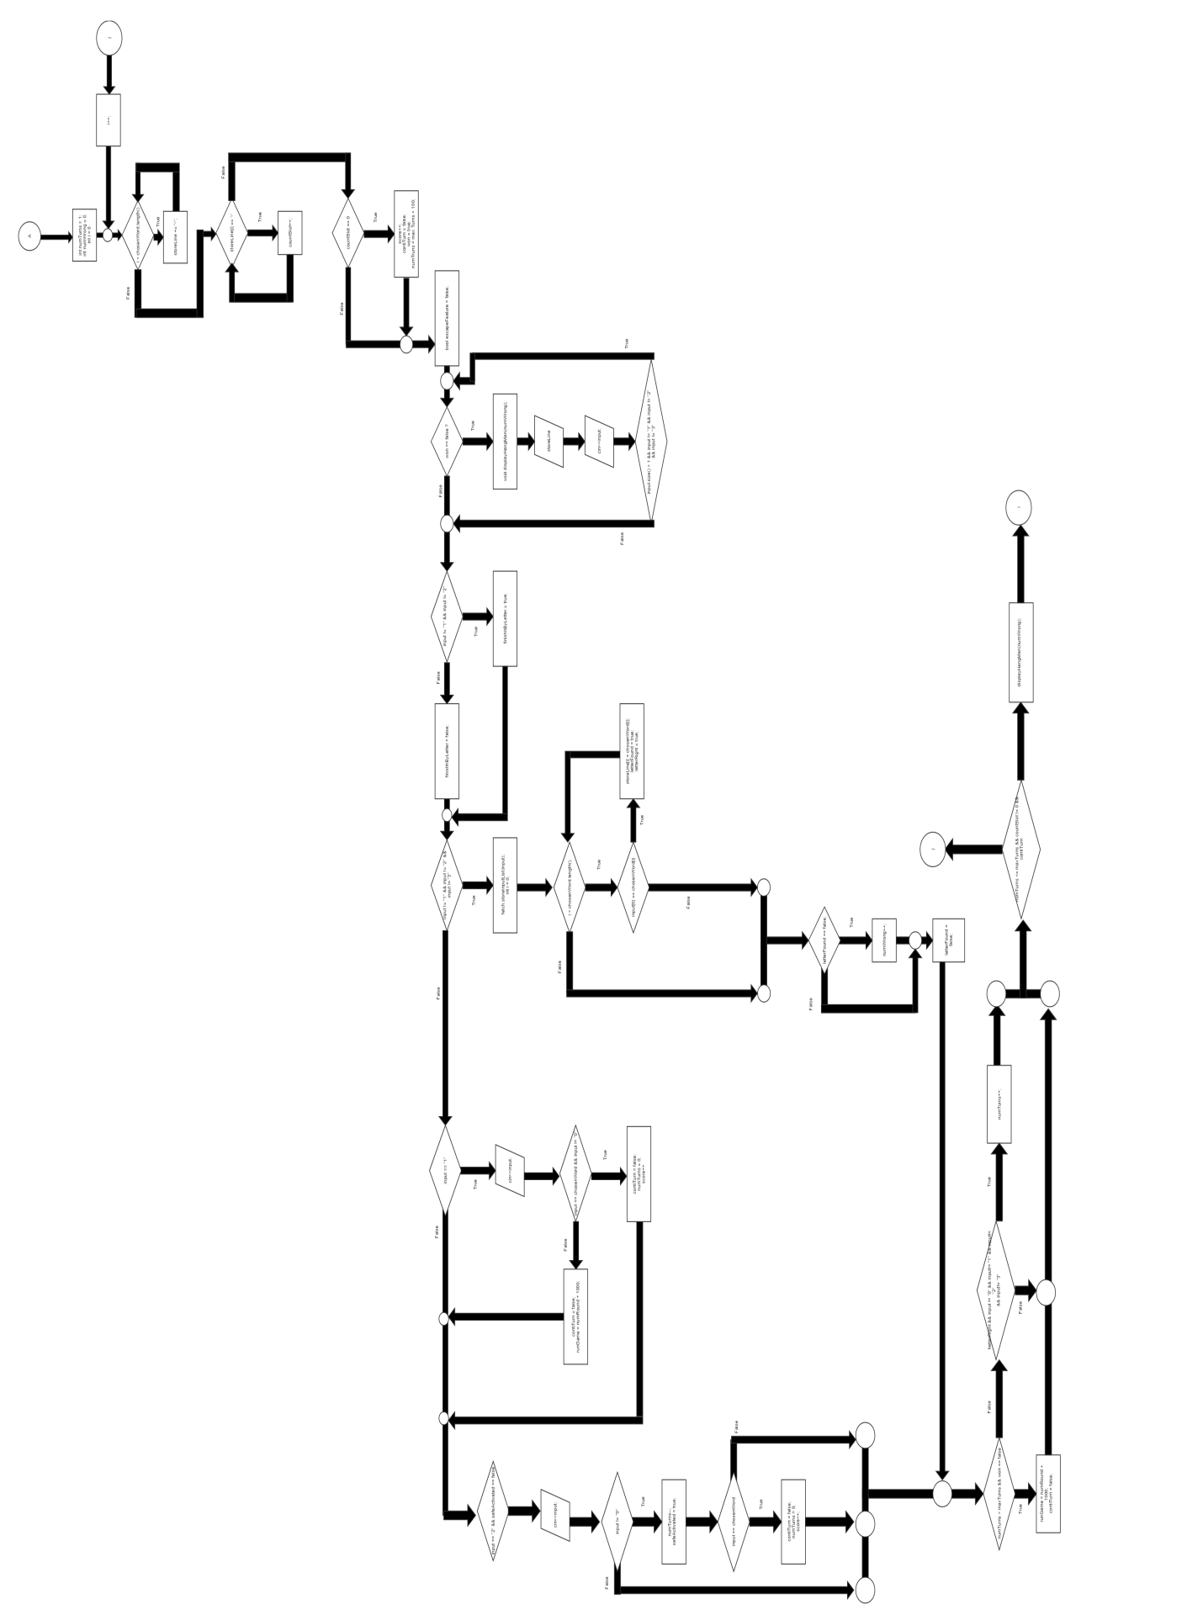

**Pseudo Code**

*Initialize*

*Display menu*

*If ‘1’ is entered from the menu (Normal Mode has been selected)*

*Select obtain random word from words.txt*

*Set numRound = 1;*

*Set maxRound = 6;*

*Display characterized graphics*

*Request Input*

*If input == “1”*

*Request player to guess word*

*If input == chosenWord*

*Then win game*

*Else*

*Then lose game*

*Else if input == “2”*

*Request player to guess word*

*If input == chosenWord*

*Then win game*

*Else*

*Continue turn*

*Else if input == “3”*

*Then display sorted inputs from STL’s List*

*Else if input == letter in chosenWord*

*Then continue turn*

*Else if ‘2’ is entered from the menu (Ez-Mode has been selected)*

*Obtain 25 words from words.txt*

*Insert those 25 words into STL’s Set*

*Calls function to the core of the game*

*Use Iterator to display all elements of STL’s Set and pick a random word from it*

*Display characterized graphics*

*Request Input*

*If input == “1”*

*Request player to guess word*

*If input == chosenWord*

*Then win game*

*Else*

*Then lose game*

*Else if input == “2”*

*Request player to guess word*

*If input == chosenWord*

*Then win game*

*Else*

*Continue turn*

*Else if input == “3”*

*Then display sorted inputs from STL’s List*

*Else if input == letter in chosenWord*

*Then continue turn*

*Else if ‘3’ is entered from menu (Marathon Mode has been selected)*

*Run Marathon Mode*

*Request for number of rounds*

*Obtain words based on number of rounds*

*Push words on to STL’s Stack*

*Pop a word from Stack from for each round*

*Checks if letter is in words*

*Else if ‘4’ is entered from menu (Custom Word Mode has been selected)*

*Run Custom Word Mode*

*Requests number of rounds*

*Requests a word to be entered for each round*

*Push word on to STL’s Queue*

*Pop word from STL’s Queue for each round*

*Run core game*

*Else if ‘5’ is entered from menu (Show the rules)*

*Then display the rules*

*Else if ‘6’ is entered from menu (Show the Score Board)*

*Then display the names and scores from STL’s Map*

*Else if ‘7’ is entered from the menu (Show the Ez-Mode free words that has been chosen)*

*Use Iterator to go through STL’s Set to display the list of words chosen only for Ez- Mode*

**Major Variables**

|  |  |  |  |
| --- | --- | --- | --- |
| **Type** | **Variable Name** | **Description** | **Location** |
| Integer | numTurns | Stores the number of rounds | void coreGame(int, string) |
|  | numWrong | Stores the number of wrong inputs | void coreGame(int, string) |
|  | countSlot | Counts for amount of open slots left | void coreGame(int, string) |
|  | score | Stores the score for each word correct | void coreGame(int, string) |
|  | newScore | Obtains the score for class Scoreboard | Class Scoreboard |
| string | input | Stores player’s input | void coreGame(int, string) |
|  | chosenWord | Stores the word chosen for the round | void coreGame(int, string) |
|  | storeLine | Displays progress of unknown word | void coreGame(int, string) |
|  | *wordList | Stores the string for class WordFetch | class WordFetch |
| char | input | Store yes/no choice for confirmations with player | void Scoreboard::requestUsername(); |
| bool | won | Holds winning status | void coreGame(int, string) |
|  | safeActivated | Holds if player has activated their lifeline | void coreGame(int, string) |
|  | escapeFeature | Holds if player has exited guess word mode | void coreGame(int, string) |
|  | wrongWord | Holds if the wrong word has been guessed | void coreGame(int, string) |
|  | letterFound | Alerts game if letter has been found | void coreGame(int, string) |
|  | contiTurn | Holds if turn should continue after guessing word mode | void coreGame(int, string) |
|  | finishByLetter | Holds if player previous turn was Letter Mode | void coreGame(int, string) |
|  | letterRight | Holds if guessed letter is correct | void coreGame(int, string) |

**Concepts**

**Maps:** Located in ***Scoreboard.cpp*** (Lines: 88 -189)

**Sets:** Located in ***WordFetch.cpp*** (Lines: 90 – 201)

**Lists:** Located in ***WordFetch.cpp*** (Lines 203-230)

**Stacks:** Located in ***WordFetch.cpp*** (Lines 233-261)

**Queues:** Located in ***WordFetch.cpp*** (Lines 264-300)

**Iterators:** Located in ***Scoreboard.cpp*** (lines 103-105), ***WordFetch.cpp*** (lines: 117 & 189-194 & 221-223)

**Algorithms:** Located in ***WordFetch.cpp*** (lines: 117), ***Hangman.cpp*** (lines: 437), ***Scoreboard.cpp*** (Line 143)

**Reference**

1. The C++ Standard Library by Nicolai M. Josuttis
2. www.cplusplus.com
3. Introduction to Algorithms (Third Edition) by Charles E. Leiserson

**Program**

**//filename: main.cpp**

#include <ctime>

#include <cstdlib>

#include <iostream> //For input output

#include <fstream> //Use to obtain words from words.txt

#include "WordFetch.h"

#include "Hangman.h"

using namespace std;

int main(int argc, char** argv) {

srand(time(NULL));

//Declares object for Hangman class

Hangman h;

//Display the Hangman title on the screen

h.titleDisplay();

//Displays the menu to select game mode

h.menuDisplay();

return 0;

}

**//filename: Hangman.cpp**

#include <cstdlib>

#include <iostream>

#include <ctime>

#include "Hangman.h"

#include "WordFetch.h"

#include "Scoreboard.h"

#include <algorithm> //To use STL's sort algorithm

using namespace std;

void Hangman::coreGame(int numRound, string mode){

int countSlot = 0; //counts the value for open slots left

bool won = false; //holds winning status

bool safeActivated = false; //Checks if player has activated their lifeline

bool escapeFeature = false; //Checks if player has exited guess word mode

bool wrongWord = false; //Checks if the wrong word has been guessed

int score = 0; //Stores the number points

int numTurns = 1; //Stores the number of turns

int numWrong = 0; //Store the number of wrong guesses for letters

string chosenWord; //Stores the word chosen for the round

int randNum; //Stores a random number for choosing word

bool letterFound = false; //Alerts game if letter has been found

const int maxTurns = 6; //Holds number of max turns per round

string input; //Stores player's input

bool contiTurn = true; //Checks if turn should continue after guessing word mode

bool finishByLetter = false; //Checks if player previous turn was Letter Mode

bool letterRight = false; //Checks if guessed letter is correct

//Holds the status of guessed characters and open slots left

string storeLine = "";

srand(time(0));

//Do-Whole loops the number of rounds a game mode offers

//Also increments the number of rounds in its condition

for(int runGame = 1; runGame <= numRound; runGame++){

/**********************************

* Setting Up Round *

**********************************/

fetch.deleteInputHist();

contiTurn = true;

won = false;

safeActivated = false;

finishByLetter = false;

letterFound = false;

//Determines how chosenWord is selected depending on game mode

if(mode == "ez"){

fetch.DisplayListSet();

fetch.removeWordEZMode();

chosenWord = fetch.getEzWord();

}else if(mode == "marathon"){

cout<<"\nNOTE: Unless you've guessed the wrong word under challenge"

<<" mode \"Word Mode\" (Option \"1\") you can still continue "

<<"and play.\n You'll just not get a point for that word.\n";

if(!fetch.stackIsEmpty())

chosenWord = fetch.popWordMarathon();

}else if(mode == "custom"){

if(!fetch.queueIsEmpty()){

chosenWord = fetch.getWordCustom();

}

}else if(mode == "normal"){

fetch.setWords(1);

chosenWord = fetch.getWord();

}else{

cout<<endl<<"Error: Game Mode has not been selected correctly.";

cout<<" Now terminating...\n";

contiTurn = false;

runGame = numRound + 1000;

}

cout<<endl<<"(for testing purposes) chosenWord = "<<chosenWord<<endl;

//Holds the status of guessed characters and open slots left

storeLine = "";

//For-loop that checks the number of open slots base on

//the length of the chosen word for the round

for(int i = 0; i < chosenWord.length(); i++){

storeLine+="-";

}

cout<<endl;

//Reset for new round

numTurns = 1;

numWrong = 0;

/**********************************

* Starting Game *

**********************************/

//Do-while loop: Checks the winning conditions

do{

cout<<"\n\t\t\t\t Try: "<<numTurns<<"/"

<<maxTurns<<endl;

letterRight = false; //Resets if player guessed letter right

//Resets countSlot to 0 for every round

//checks if player has won

countSlot = 0;

//For-loop that assigns the number of open slots base on

//the length of the chosen word for the round

for(int i = 0; i < chosenWord.length(); i++){

//Increments countSlot for every open slots avaliable

if(storeLine[i] == '-'){

countSlot++; //counts the amount of open slots left

//if count == 0 then player wins

}

}

//If there are no open slots left then word has been guess

//Therefore player has won

if(countSlot == 0){

score++;

contiTurn = false;

won = true;

numTurns = maxTurns + 100; //Terminates do-while loop round

//if word has been guessed in

//Letter Mode

}

escapeFeature = false;

if(won == false){

//inner while loop: Prompts the player to enter guessed

//character or select one of the following features

//Feature #1: Guess word and instantly lose

//Feature #2: A once per round life line where incorrectly guessed

//word will not cause the player to lose

do{

//Displays the appropriate hangman image based on amount of

//wrong guesses

displayHangMan(numWrong);

//Displays status of guessing the word

cout<<endl<<storeLine<<endl;

cout<<"Enter \"1\" to guess word. (Will lose instantly if "

<<"guessed wrong.)\n";

//Opens up game feature to allow a free mode where guessing

//a word wrong will not harm player's status of winning

if(safeActivated == false)

cout<<"Enter \"2\" to guess word without losing. "

<<"(Once per round)\n";

cout<<"Enter \"3\" to see numbers you have previously entered\n";

//Prompts player for input

cout<<"Enter a letter: ";

cin>>input;

if(input == "3")

fetch.displayInputList();

if(input == "2" && safeActivated == true)

cout<<"\nSorry. You have already used up your life line"

<<" (Option 2). You must wait for the next round "

<<"to use it again.\n";

//Warns the player if they've enter too many letters

if(input.size() > 1)

cout<<"\nInvalid Input: You must only enter 1 character. "

<<"Please enter \"1\" or if you haven't \"2\" to"

<<" guess the entire word.\n";

//do-while loop checks for activation of features and size of

//input

//If player chooses one of the two options above, it will then

//terminate this do-while loop to proceed them to the next

}while(input.size() > 1 && input != "1" && input != "2"

&& input != "3");

//Checks what the previous mode was

if(input != "1" && input != "2")

finishByLetter = true;

else

finishByLetter = false;

//Stores the guessed values per turn

if(input != "1" && input != "2" && input != "3"){

fetch.storeInputList(input);

}

//Checks if inputed character is present in the chosen word

if(input != "1" && input != "2" && input != "3"){

for(int i = 0; i < chosenWord.length(); i++){

for(int j = 0; j < chosenWord.length();j++){

if(input[0] == chosenWord[i] ){

storeLine[i] = chosenWord[i];

letterFound = true;

letterRight = true;

}

}

}

//Keeps track of the number of wrong guesses

if(letterFound == false)

numWrong++;

letterFound = false; //resets found letter to false for

//the next turn

// numTurns++; //Incrementor for number of rounds

//Unlocks word guessing mode

}else if(input == "1"){

cout<<endl;

cout<<"BEWARE: Guess the word correctly and you will automatic"

<<"ally win the game.\nGuess the wrong word and you will"

<<" instantly lose.\n";

cout<<"If you're not up for it, enter \"0\" to return to "

<<"guessing only letters.\n";

cout<<"Enter the word: ";

cin>>input;

if(input != "0"){

if(input == chosenWord){

cout<<"*** You've guessed the correct word! "

<<"You have WON! ***"<<endl;

contiTurn = false;

numTurns = 0;

score++;

}else{

cout<<"\nYour guess was wrong. You Lose\n";

contiTurn = false;

runGame = numRound + 1000;

}

}

//Unlocks the safe feature of the game

}else if(input == "2" && safeActivated == false){

cout<<endl;

cout<<"Warning: You'll only have safety mode once per turn.\n";

cout<<"Safe Mode --- You will not lose a guess if word is "

<<"guessed incorrectly.\n";

cout<<"Enter \"0\" if you do not wish to use up this feature.\n";

cout<<"Enter the word: ";

cin>>input;

if(input != "0"){

numTurns--; //Does not count turn if life mode

safeActivated = true;

if(input == chosenWord){

cout<<"*** You've guessed the correct word! "

<<"You have WON! ***"<<endl;

contiTurn = false;

numTurns = 0;

score++;

}

}

}

}

//Terminates the for-loop if player loses a turn in letter mode

//In other words, GAMEOVER

if(numTurns > maxTurns && won == false){

runGame = numRound + 1000;

contiTurn = false;

}

if(!letterRight && input != "0" && input!= "1" && input!= "2"

&& input!= "3")

numTurns++;

}while(numTurns <= maxTurns && countSlot != 0 && contiTurn);

//Redisplay man's status

displayHangMan(numWrong);

//Informs player of the game's outcome before game ends

if(finishByLetter == true){

if(won == true){

cout<<"\n*** YOU'VE WON ***\n";

}else

cout<<"\n*** You lose. Better luck next time! ***"<<endl;

}

//Displays the word at the end of the game

cout<<endl<<"Answer: "<<chosenWord<<endl;

} //End of for-loop

//Takes in score for scoreboard

sc.setScore(score);

//Requests if player wants to enter a username and have score be stored

sc.requestUsername();

//Displays scoreboard of previous players

sc.readNameScore();

menuDisplay();

}

**//filename: Scoreboard.cpp (not entire file)**

**********************************************************

* Map - *

* Used to store and display both usernames & score from *

* usernames.txt & scores.txt *

* ********************************************************/

//Displays the list of previous names & scores

void Scoreboard::readNameScore(){

updateNameScoreMap();

map <string, string> :: iterator itr;

cout<<endl<<endl;

cout<<"*******************************************"<<endl;

cout<<"* Scoreboard *"<<endl;

cout<<"*******************************************"<<endl;

cout<<endl;

cout<<"Players:\n";

cout<<"--------\n";

for (itr = m.begin(); itr != m.end(); ++itr){

cout << itr->first<< endl << "\tScore ----> " << itr->second<<endl;

}

cout << endl;

}

//Takes in score

void Scoreboard::setScore(int score){

newScore = score;

}

//Checks if username already exists

bool Scoreboard::checkUsername(string username){

updateNameScoreMap();

bool foundName; //Returns if username already exist or not

//Checks to see if the name on already on the map

if(m.count(username) == 0)

foundName = false;

else

foundName = true;

//cout<<endl<<endl<<"foundName = "<<foundName<<endl;

//cout<<endl<<endl<<"m.count = "<<m.count(username)<<endl;

return foundName;}

//Checks if backup username already exists too

bool Scoreboard::checkUserCode(string username){

bool foundCode = false; //Returns if username already exist or not

std::hash<std::string> str_hash;

string line;

ifstream myfile ("backup_usernames.txt");

if (myfile.is_open()){

stringstream ss; //create a stringstream

while ( getline (myfile,line) && foundCode != true){

ss << str_hash(username); //add integer to the stream

cout<<"\n\t\t\t\tss.str() = "<<ss.str()<<endl;

if(ss.str() == line)

foundCode = true;

}

myfile.close();

}else cout <<"\nReading error: Unable to open backup_usernames.txt for "

<<"cross-referencing with hash.\n";

//cout<<endl<<endl<<"foundCode = "<<foundCode<<endl;

return foundCode;}

//Updates the map dealing with the scoreboard

void Scoreboard::updateNameScoreMap(){

string lineName;

string lineScore; //temporary string for each line in .txt

int countLine = 0; //Counts the number of lines (elements) in .txt

int i = 0; //incrementer

ifstream myfileCount ("usernames.txt");

while(getline (myfileCount, lineName) ){

countLine++;

};

myfileCount.close();

//Reading files usernames.txt & scores.txt to insert into map

ifstream myfileName ("usernames.txt");

ifstream myfileScore ("scores.txt");

if (myfileName.is_open() && myfileScore.is_open()){

while(getline (myfileName, lineName) && getline (myfileScore, lineScore)){

p.first = lineName;

p.second = lineScore;

m.insert(p);

};

myfileName.close();

} else

cout << "\nReading Error: Cannot open usernames.txt or scores.txt";

}

**//filename:WordFetch.cpp**

#include <cstdlib>

#include <iostream>

#include <ctime>

#include <fstream> //Use to obtain words from words.txt

#include <iterator>

#include <string>

#include <algorithm>

#include <set> //For using sets

#include <list> //For using lists

#include <stack>

#include <queue>

#include "WordFetch.h"

using namespace std;

//Access a random line in word.txt to obtain a word for Normal Mode

//Some elements of this function was borrowed from cplusplus.com

string WordFetch::getRandWords(){

ifstream myfile("words.txt"); //Access .txt for list of words

string line = "";

int numOfWords = 0;

string newword = "";

string word = "";

int wordlength = 0;

int k = 0;

string alphabet="a b c d e f g h i j k l m n o p q r s t u v w x y z"; //used for validation

while(getline(myfile, line)){

numOfWords++;

};

int index = rand()%numOfWords + 1;

//Reset curser to first line

myfile.clear();

myfile.seekg(0, ios::beg);

//Grab line from file

for (int lineno = 0; getline (myfile,newword) && lineno < index; lineno++);

wordlength=string(newword).size();

word="";

for (int i = 0; wordlength>i; i++){

for (k = 0; k < 51; k+=2) //Alphabetic Checks

if (alphabet[k]==newword[i]) //Check if letter is in alphabet

word=word+newword[i];

}

return word;}

//Obtains number of words based on number of rounds

void WordFetch::setWords(int nRounds){

numRounds = nRounds;

string tempWord = "";

int count = 0;

wordList = new string[numRounds];

for(int numWords = 0; numWords < numRounds; numWords++){

tempWord = getRandWords();

wordList[numWords] = tempWord;

}

//for(int m = 0; m < numRounds; m++)

//cout<<endl<<"word = "<<wordList[m]<<endl;

}

//Destructor deallocates memory

//Update word list if new custom words have been added

WordFetch::~WordFetch(){

//If queue is not empty then it will write its existing words onto the list

if(!q.empty()){

//****** Updating library ******

//Cleans duplicate entries

//Organizes words in ABC order

fstream fileUpdateWords;

fileUpdateWords.open("words.txt", fstream::app);

if (fileUpdateWords.is_open()){

while(!q.empty()){

fileUpdateWords<<q.front();

q.pop();

};

fileUpdateWords.close();

}else

cout<<"\nWriting Error: Cannot open words.txt to update library.\n";

}

delete[] wordList;

}

/**********************************************************

* Set - *

* Use to single insert words into words.txt and display *

* entire list in alphabetical order with built in sort *

* ********************************************************/

void WordFetch::wordsInSet(){

string line;

const int numFreeWords = 25;

ifstream myfileWords ("words.txt");

if (myfileWords.is_open()){

for(int i = 0; i < numFreeWords; i++){

s.insert(getRandWords());

};

myfileWords.close();

} else

cout << "\nReading Error: Cannot open words.txt";

}

//Displays 25 free words from the list of possible words in Alphabetical order

//(utilizing STL set's built-in sort)if player wishes to see it in the menu

void WordFetch::DisplayListSet(){

cout<<"\nList of 25 Possible Free Words (Alphabetical Order):\n";

cout<<"------------------------------------------------------\n";

for(set<string>::iterator it = s.begin(); it != s.end(); it++){

cout<<*it<<endl;

}

cout<<endl<<endl<<"\n*Note: Unless playing under EZ-Mode, there is not a "

<<"definitive chance that these words will appear\nin other"

<<" game modes.\n";

}

//Removes a word from STL's Set

void WordFetch::removeWordEZMode(){

char choice; //Asks if player wants to correct their input mistake

string input; //Holds word to be removed from Set

do{

cout<<endl<<"From the list of words above, would you like to remove any "

<<"one word to improve your odds? (y/n): ";

cin>>choice;

if(choice != 'n' && choice != 'N' && choice != 'y' && choice != 'Y')

cout<<"\nSorry your has to be \"y\" for Yes or \"n\" for No.\n";

}while(choice != 'n' && choice != 'N' && choice != 'y' && choice != 'Y');

if(choice == 'y' || choice == 'Y'){

DisplayListSet(); //Redisplay list from set for player to select

//Requests player to select a word from set

cout<<"\nEnter a word you'd like to remove from the list above: ";

cin>>input;

int n = 3; //number of attempts

//Confirms the inputted word exists and removes it

while(choice != 'n' && choice != 'N' && s.count(input) == 0 && n > 0){

cout<<"\t\t\t\t\t\t"<<n--<<" Attempt(s) Left\n\n";

if(s.count(input) == 0){

cout<<"The word \""<<input<<"\" does not exist.\n";

cout<<"\nWould you like to try again? (y/n): ";

cin>>choice;

if(choice == 'Y')

choice = 'y';

else if(choice == 'N')

choice = 'n';

if(choice != 'n' && choice != 'y')

cout<<"\nSorry your input has to be \"y\" for Yes or \"n\""

<<"for No.\n";

else if (choice == 'y'){

cout<<"\nEnter another word to be removed: ";

cin>>input;

}

}

};

if(s.count(input) > 0)

s.erase(input);

}

}

//Obtain a word for Ez-Mode with the use of STL's Set

string WordFetch::getEzWord() const{

string ezWord;

int randomNum = rand()%s.size() + 1;

int i = 0;

for(set<string>::iterator it = s.begin(); it != s.end(); it++){

i++;

if(i == randomNum)

ezWord = *it;

}

return ezWord;

}

//Clears the set

void WordFetch::clearWordListSet(){

s.clear();

}

/******************************************

* List - *

* Used store previous inputs of a round *

* ****************************************/

//Pushes inputed value onto the list

void WordFetch::storeInputList(string input){

l.push_front(input);

}

//Use to display player's input for the round so that they could see

//the letters they've already guessed

void WordFetch::displayInputList(){

cout<<"\nPrevious Inputs (from Latest to Oldest) RESETS FOR EVERY NEW WORD:\n";

cout<<"--------------------------------------------------------------------\n";

for(list<string>::iterator it = l.begin(); it != l.end(); it++){

cout<<"\t\t\t"<<*it<<endl;

}

}

//Deletes input history list (after every round)

void WordFetch::deleteInputHist(){

l.clear();

}

/******************************************

* Stacks (LIFO)- *

* Used store strings for marathon mode *

* ****************************************/

//Pushes all the words onto the stack when Marathon Mode is selected

void WordFetch::wordsInStack(){

for(int i = 0; i < numRounds; i++)

st.push(wordList[i]);

}

//Returns a popped value from the stack for Marathon Mode

string WordFetch::popWordMarathon(){

//Pops the list when STL's stack is not empty

if(st.empty() != true){

string temp = st.top();

st.pop();

return temp;

}else

//Warns player stack is empty

cout<<"\nThere are no longer any elements on the stack.\n";

return 0;}

//Informs if stack is empty for outside classes

bool WordFetch::stackIsEmpty(){

return st.empty();

}

/******************************************

* Queues (FIFO) - *

* Uses Queue to display custom words *

******************************************/

//Pushes custom words onto queue for Custom Word Mode while updating library

void WordFetch::queueCustomWords(string customWord){

q.push(customWord);

/****** Updates library ******/

fstream fileUpdateWords;

fileUpdateWords.open("words.txt", fstream::app);

if (fileUpdateWords.is_open()){

fileUpdateWords<<customWord<<endl;

fileUpdateWords.close();

}else

cout<<"\nWriting Error: Cannot open words.txt to update library.\n";

}

//Returns custom words from queue

string WordFetch::getWordCustom(){

if(!q.empty()){

string temp = q.front();

q.pop();

return temp;

}else

cout<<"\nThe queue of custom words is empty.\n";

return 0;}